*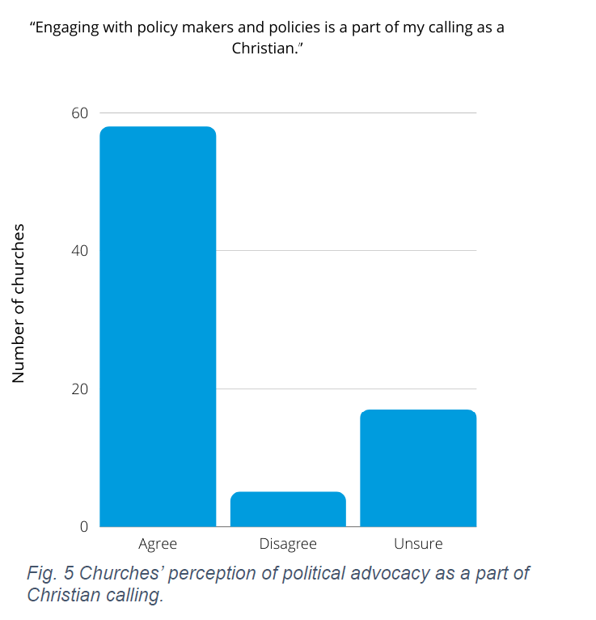Survey of Mennonite Congregations in US (2020; n=88)* 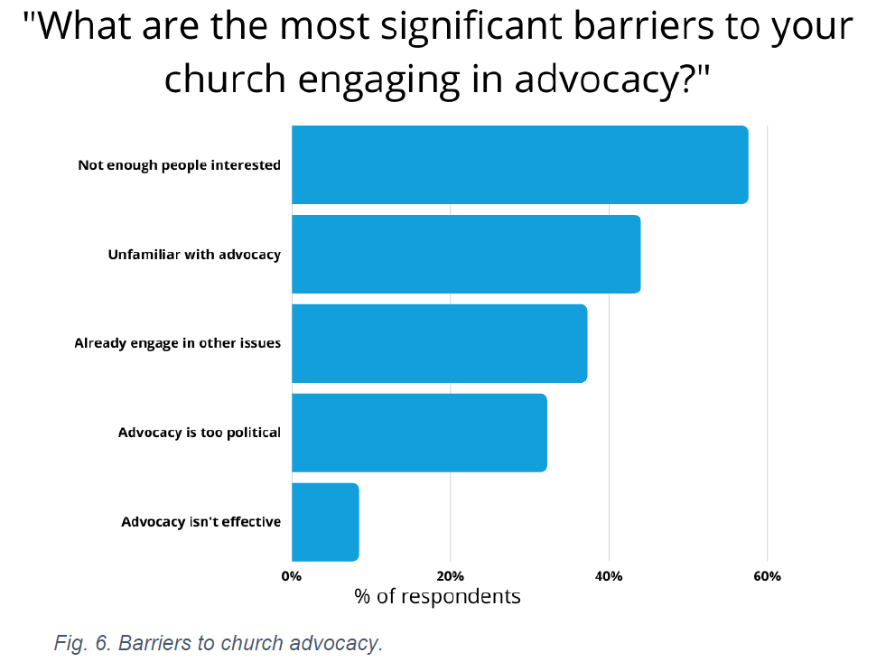 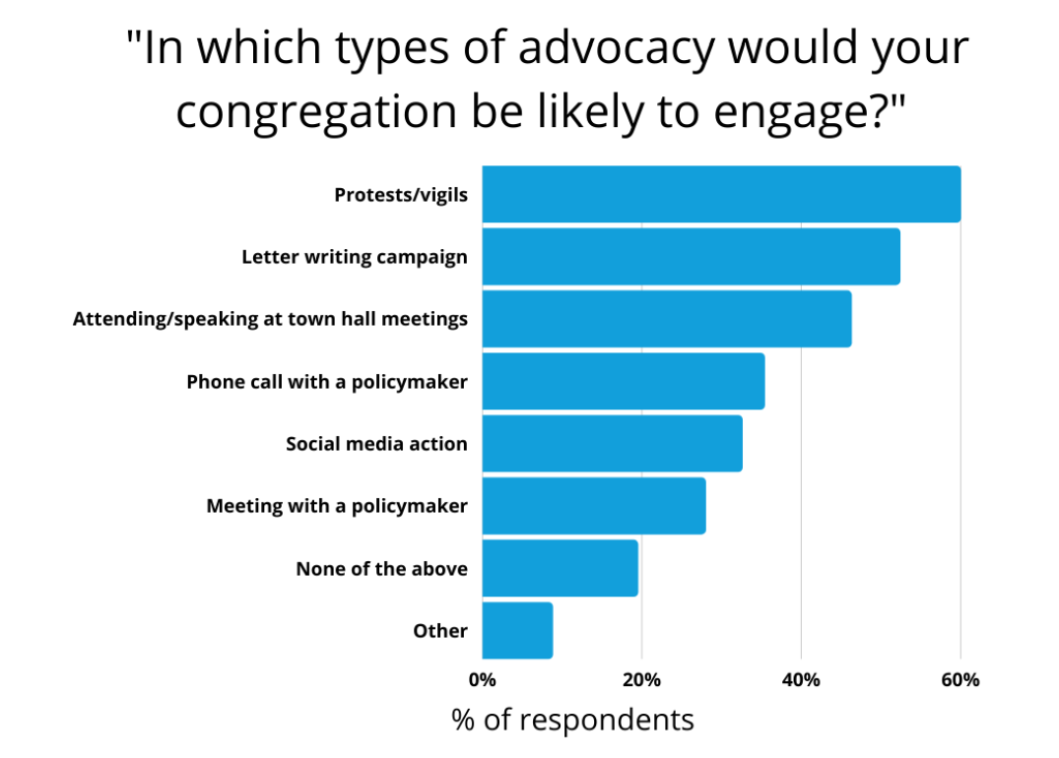

Survey of Anabaptists worldwide (2020, n=353)

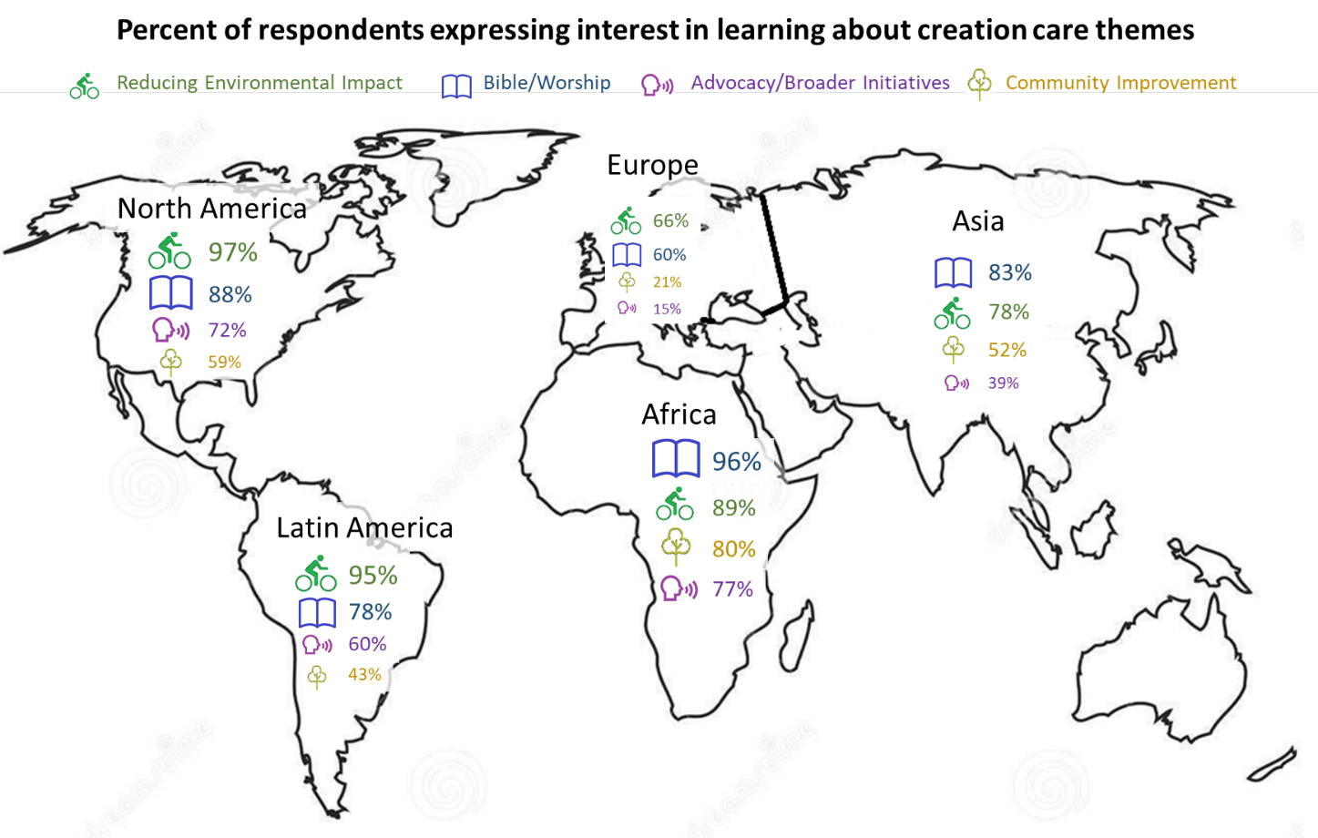

Percent responding on emotions around climate change

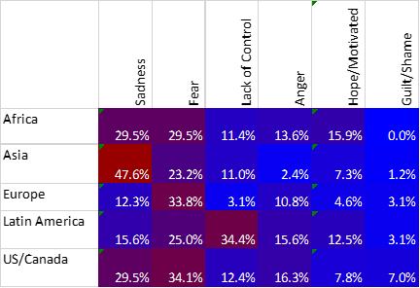

Student survey, from US Mennonite colleges/universities (n=515)



*(individual colleges coded A-G)*

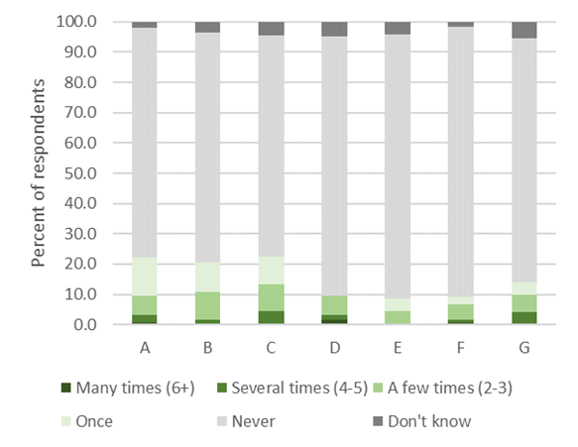

-------------------------------------------------------------------------------------



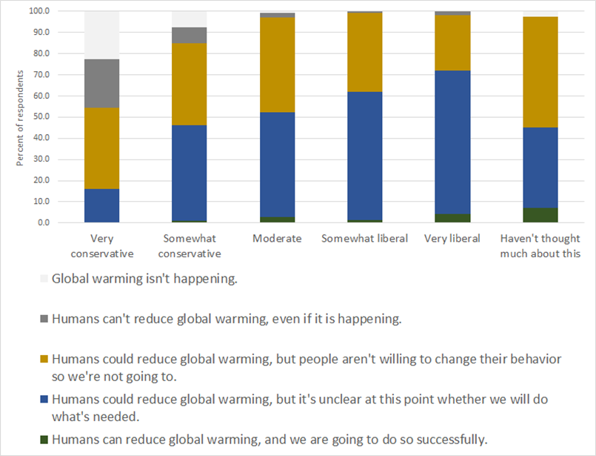



---------------------------------------------------------------------------------------------

*If you try to reduce energy or fuel use, what is your primary reason for doing so? (Mark all that apply)*

